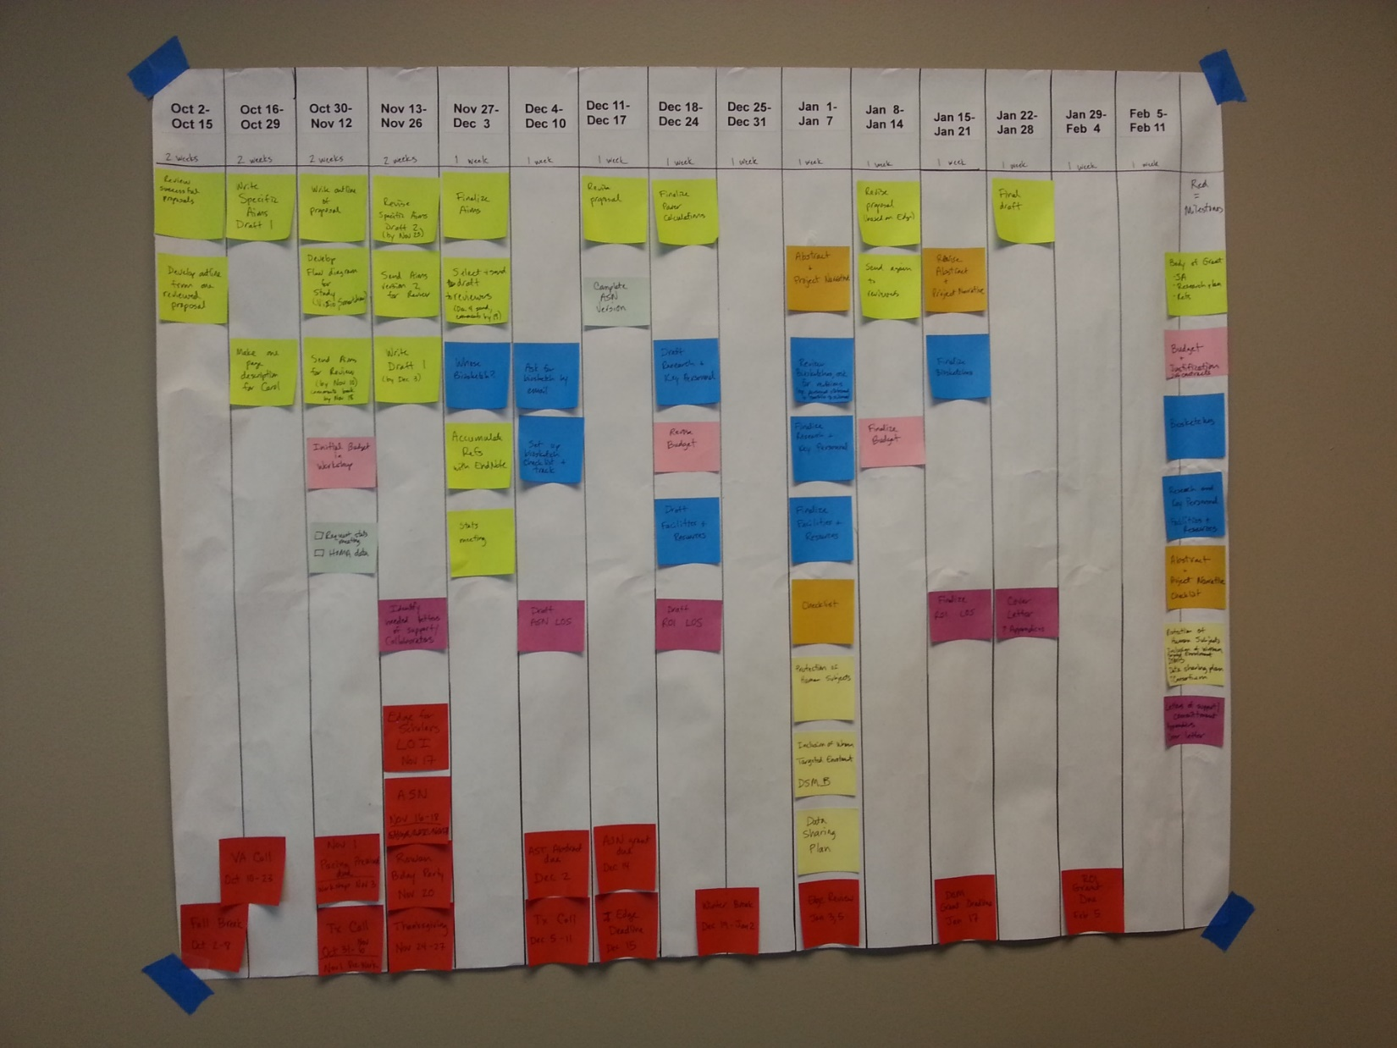
Milestones
Legend for timeline
(Buckets of work)

